

Table of Contents

[1. About this Guide 3](#_Toc492635358)

[2. About Energy Management Solution Accelerator 3](#_Toc492635359)

[3. Intended Audience 3](#_Toc492635360)

[a. Super Admin User: 3](#_Toc492635361)

[b. Admin User: 3](#_Toc492635362)

[c. Regular User: 3](#_Toc492635363)

[4. Pre-requisites 3](#_Toc492635364)

[5. Setup 4](#_Toc492635365)

[a. Software Setup 4](#_Toc492635366)

[i. Login 4](#_Toc492635367)

[ii. Sign Up 4](#_Toc492635368)

[b. Hardware Setup 7](#_Toc492635369)

[6. User Instructions 7](#_Toc492635370)

[1. Regular User (also a First Time User) 7](#_Toc492635371)

[a. Web Portal 7](#_Toc492635372)

[b. Mobile Application 9](#_Toc492635373)

[2. Admin User 10](#_Toc492635374)

[a. Web Portal 10](#_Toc492635375)

[b. Mobile Application 12](#_Toc492635376)

[7. Frequently Asked Questions 15](#_Toc492635377)

# About this Guide

The purpose of this user guide is to assist users in setting up and managing Energy Management solution. This will walk the user step-by-step through the setup process & usage guidelines of the solution.

# About Energy Management Solution Accelerator

Energy Monitoring Solution is a smart way of tracking and managing energy consumption in a specific premise or building by leveraging the Internet of Things. The solution helps facility owners get specific and detailed reports about particular sections that are energy guzzling or prone to energy wastage. The solution enables facility owners to optimize energy consumption and reduce wastage through real time monitoring and predictive analytics thereby resulting in lowering energy bills.

# Intended Audience

This guide is intended for facility managers who want to use the system. The guide explains different flows for following user roles:

## Super Admin User:

1. First user to register on the portal is assigned the Super Admin role.
2. Super admin, on request, can change the role of users to admins.
3. Super admin has access to all the configurations in the portal.

## Admin User:

Super Admin can tag an Admin to a premise to which the Admin has been assigned access. Admin can manage the portal according to the permission set by the Super Admin.

## Regular User:

1. Users have access only to the feedback section of the web portal where they can view the feedback results.
2. Users can use the mobile app which contains user specific information in the Dashboard and alerts. They can give feedback of rooms using the mobile application.

# Pre-requisites

1. Your Azure administrator has deployed the Energy Management Accelerator on an azure account and you have access to this deployed solution.
2. Web application Login URL: https://<Front-end web app name>.azurewebistes.net (this name is assigned during the deployment process, refer deployment guide for details)
3. Rest API URL for Mobile app: https://<Back-end web app name>.azurewebistes.net (this name is assigned during the deployment process, refer deployment guide for details)
4. Allow notifications in the browser to receive alerts.
5. The first user to register, will be registered as Super Admin of this portal.
6. Registrations following the Super Admin will be considered as users.
7. When required, Super Admin can change the role of a user to admin.
8. There are two versions of this portal - Admin and User portal. This User Guide details only the Admin version. User version is a subset of the Admin version with only access to the feedback score.
9. Users must raise a request to respective tenant admin to secure Admin access.
10. On field/lab setup of the reference hardware is already installed on a given premise. See section 5 b for hardware list.

# Setup

## Software Setup

## Login

* From the browser, enter the web [**URL**](#WebURL) to open the application.
* The portal is best viewed in **Edge browser.**

## Sign Up

To get started, users must first register on the portal. To register:

1. Enter a valid email address. Email addresses which are already registered cannot be used again.
2. Click on **‘Send Verification Code’**. A verification code will be sent to the email address entered.
3. Enter the verification code to complete the sign-up process.
4. After sign-up, user will be registered as **non-admin** **user**. To change the role to **Admin or Super Admin**, user must update the role to Admin User from configuration settings.

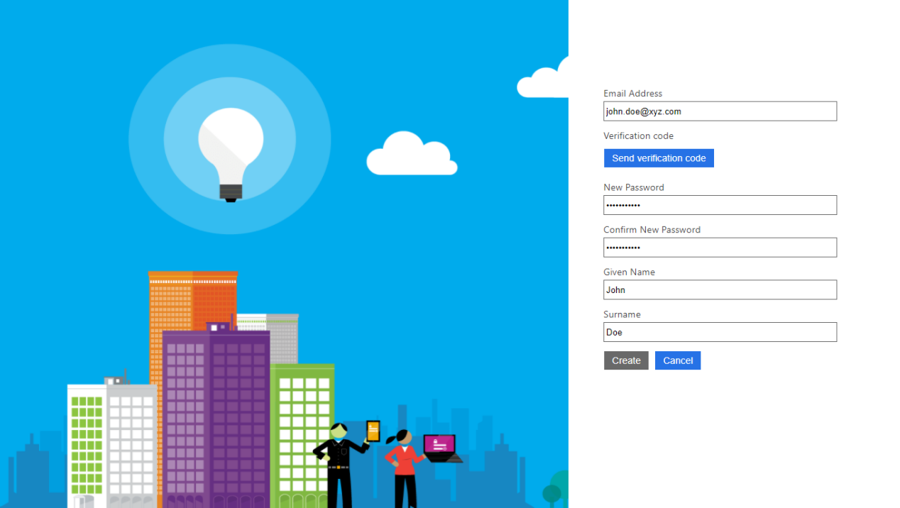

* + 1. **Sign In**
       1. Use the sign-up credentials to log in and start viewing the portal.
       2. Contact administrator to change the password.

**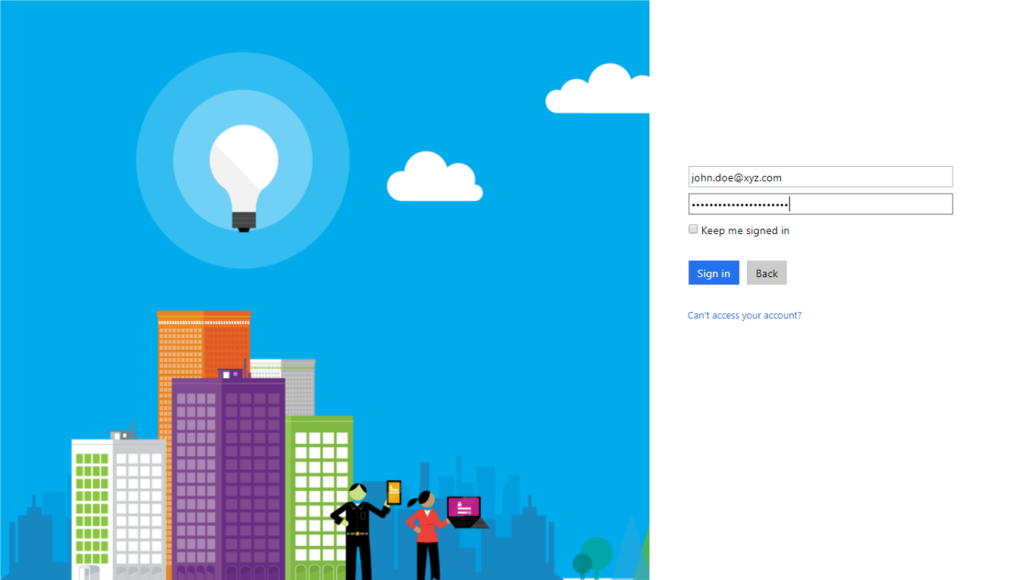**

* + 1. **Change Avatar**

To change/update avatar, click on the existing avatar and then choose a new one.

**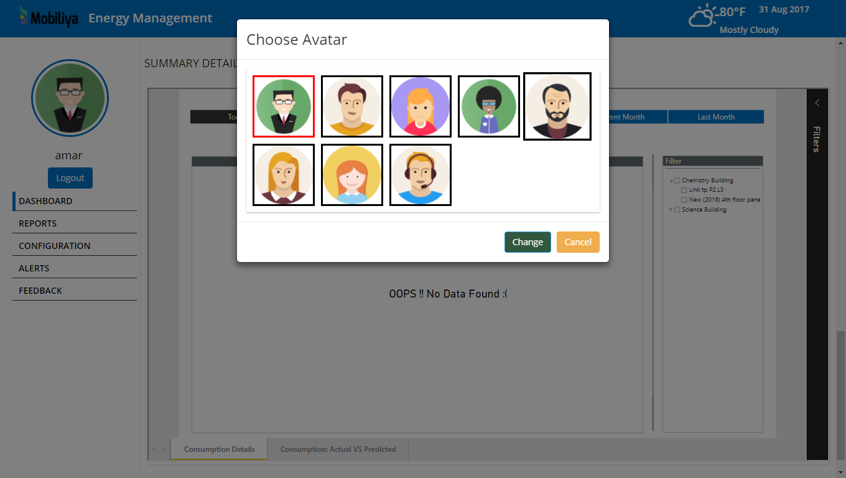**

## Hardware Setup

Following is the list of the reference hardware used in the solution. Users can install these devices in a lab or on an actual premise. It is left to the user to look in the individual reference guides for the connections of these devices together, and the recommended settings.

Once these devices are connected together, PI server connectors (as mentioned in the deployment guide) needs to be configured so that the data can flow in the system.

|  |  |
| --- | --- |
| **Device** | **Description** |
| PowerScout from Dent Instruments | Either powerscout 24 or powerscout 3037 |
| Dell 5000 Edge Gateway | To install OSISoft components |
| WiFi Sensortag (wirelesstag.net) | For getting the environmental data |
| Mobile Device | Any Android/iOS device |
| CTScanner | For measuring current & voltage. This needs to be compatible with the powerscout |

# User Instructions

## Regular User (also a First Time User)

### Web Portal

#### Feedback

After logging in, user can view the feedback of the selected room. User can select different rooms from the drop-down menu on the right side of the screen.

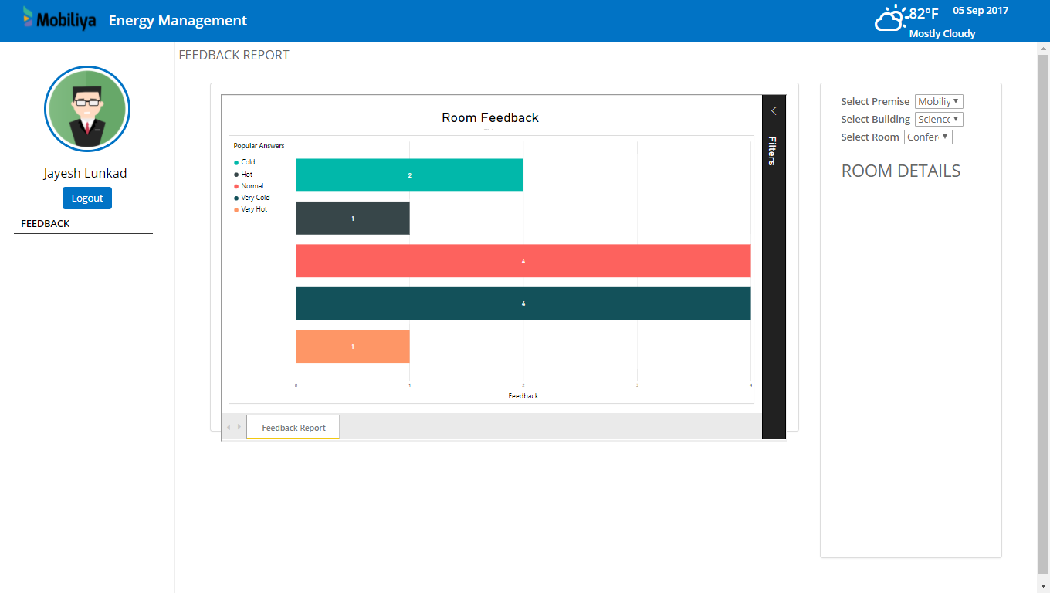

**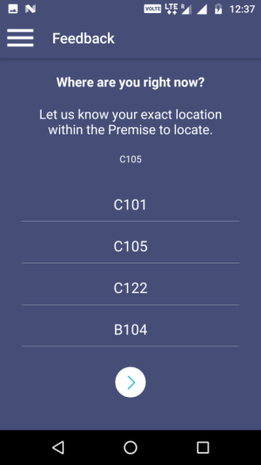**

### Mobile Application

#### Menu – Feedback

- When a Non admin user logs in, only the **Feedback Screen** is visible. Non admin users are only allowed to submit feedback for listed rooms.

- To submit feedback, select a room and click **Next**. Select a suitable answer and click on (✓) to submit feedback.

- When an answer is selected, the background color changes as per selected answer.

- On submitting feedback, it checks the feedback ratio of each feedback for that room. Whenever the ratio for a single answer exceeds 60%, an alert notification is sent to Admin informing the temperature of that room.

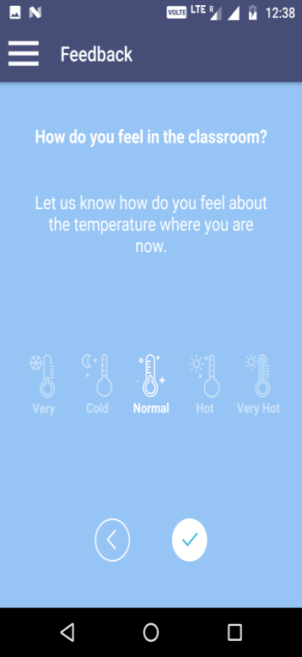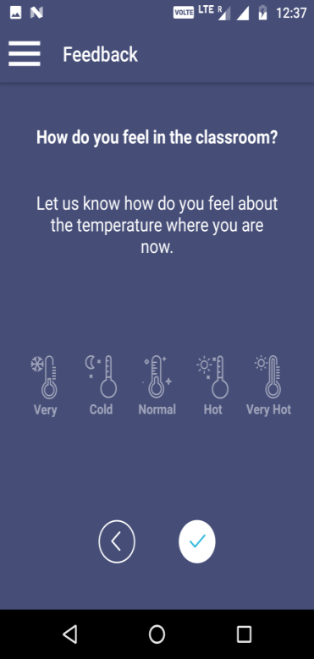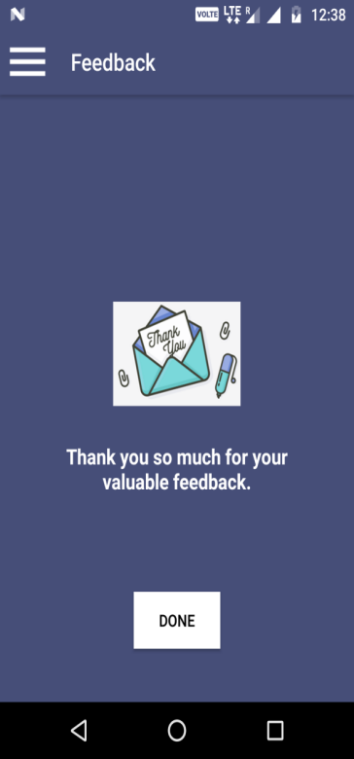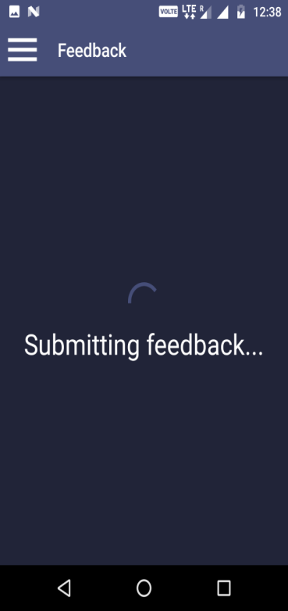

## Admin User

### Web Portal

#### Dashboard

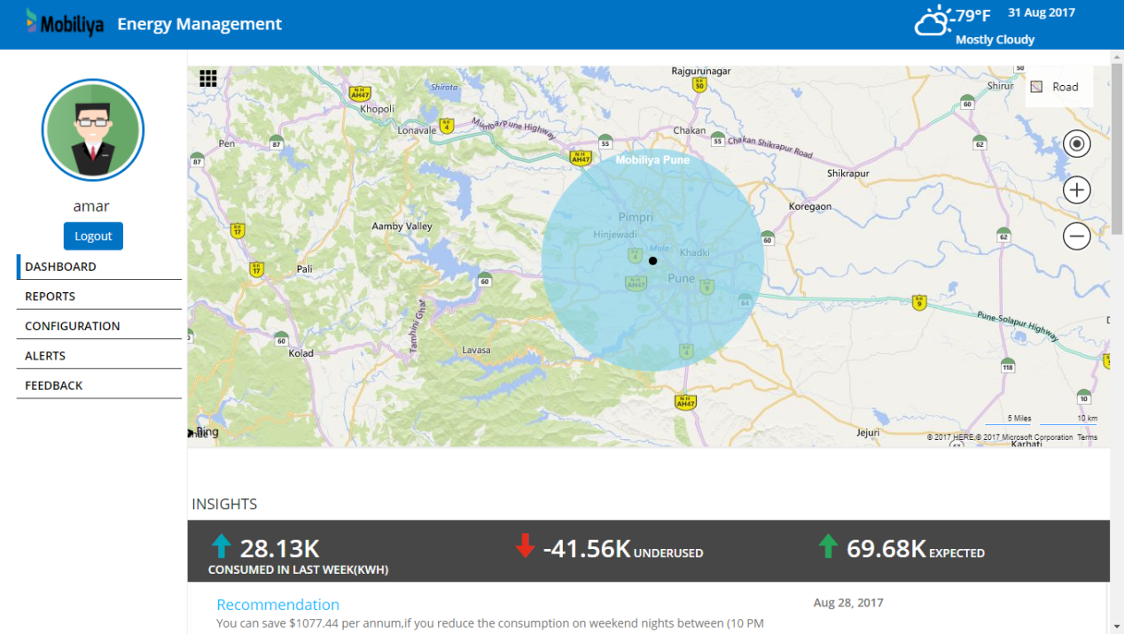

* + 1. After logging in, the Admin user can see the Enterprise Dashboard. The Enterprise Dashboard also displays all the premises to which the Admin has permission.
    2. The colored radius of the location indicates the intensity of power consumed by a particular premise or building. It is reset at beginning of every new month.
    3. The Enterprise Dashboard also displays **Recommendations** which are received on daily basis. This will keep the Admin updated on how much consumption can be saved if a particular action is taken.
    4. The Dashboard also displays **Power BI** reports which provides summary and details of energy consumption. It showcases various dimensions on which energy consumption can be sliced and diced to help Admin in taking a decision.
    5. Consumption Details page in detailed report shows consumption over a period of time to better analyze the trend. The trend can be filtered up to PowerScout/Meter level when viewed in Building level reports.
    6. Actual vs Predicted page shows consumption against actual consumption and can help you in understanding future consumption trend. The trend can be filtered up to PowerScout/Meter level when viewed in Building level reports.

**Note:**

Visuals in Detailed reports are reset at the start of every new month.

#### Reports

This section of the portal contains Organization level summary and detailed reports. They show similar metrics as mentioned in [this](#powerbireports) section, the only difference being that these reports show data across all premises of an organization.

#### Configuration

This section of the portal displays the configuration done at the set up stage. Admin can update/manage different settings from this section. For e.g. Admin can change the role of a person or add a new premise from the Configuration section.

#### Alerts

The Alerts section displays a list of any new notification that may be received. The list of alerts includes:

**i. Anomaly:** This alert is triggered when anomalies are detected by the system.

**ii. Device Alert:** This alert is triggered when a new device is registered in the system.  
Admin can view details of every alert along with a map of the room and associated sensors with each room.

In case a new sensor is added, it is featured under **Un-Mapped Sensor List**. To map a sensor against a room, Admin must drag the sensor and put it in the table against a room and click on **Associate** button.

**iii. Recommendation**: This alert is triggered daily to provide insights on saving energy & cost.

**iv. Sensor Alert**: This alert is triggered when a new sensor is registered in the system.

**v. Temperature Alert**: This alert is triggered when a feedback surpasses 60% for a particular response.

#### Feedback

a. Users can give feedback related to temperature of the room. The results of the feedback can be seen in this section.

b. Users can choose a premise, a building and a room at a time from the drop down menu.

#### Notifications

a. Push notifications related to recommendations are received every day at UTC 00:00.

b. If threshold of room feedback surpasses 60% for a response, that will also trigger a push notification.

### Screenshot_20170831-130526Mobile Application

#### 1. Configuration

- This is the launch screen for the Energy Management app.

- The Energy Management Rest API URL can be updated from here.

- It verifies if the URL is valid or not. Once a valid URL points to Energy Management, it updates the same until app data is cleared or app is uninstalled. Sample URL: https://<your backend URL>.azurewebsites.net

#### Screenshot_20170831-1307072. Login

**a. Login Screen**

Once configuration is successfully completed, the log in screen appears. User can **Sign Up** or **Sign In** from here.

User can change a password using **Forgot Password** option.

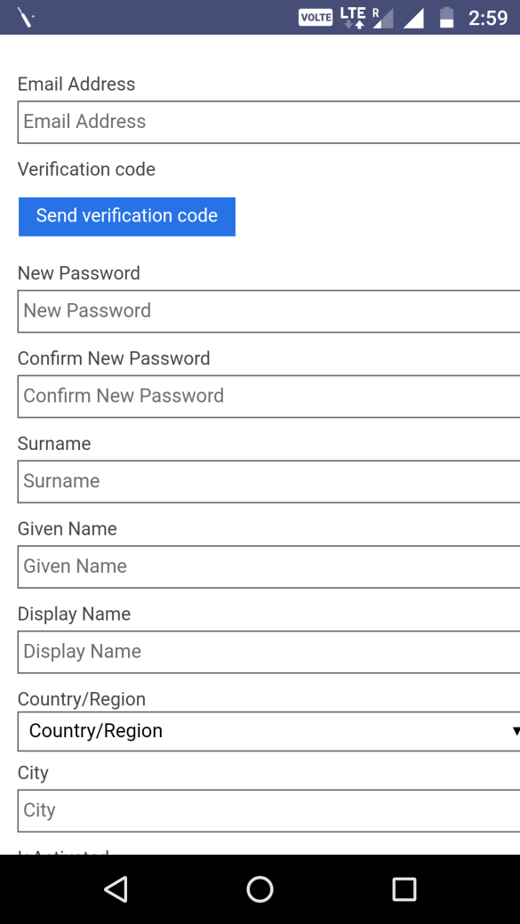

**b. Sign Up**

- Click **Sign Up** on login screen to sign up for Energy Management application.

- User needs a valid email id to register.

- By default, user is registered as a non - admin user.

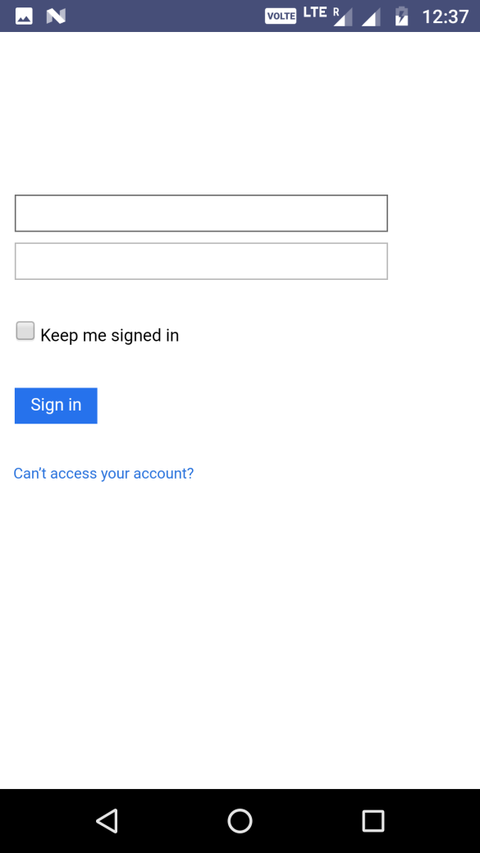- Super Admin user can change user role to Admin from the Configuration section.

**c. Sign In**

- User can login to Energy Management app using the sign-in credentials.

- After logging in Admin will see the **Admin Dashboard** while the non admin user will see the **Feedback screen**.

**d. Forgot Password**

The Forgot Password option can be accessed from the Login Screen. User can change/update password from here in case user cannot recall the existing password.

**e. Change Password**

This option is available after user logs in. User can use this option to change/update existing password.

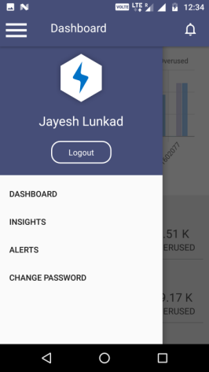**f. Menu**

The Menu option can be accessed by clicking on the top left icon. User can view current user name and other menu options.

Also, user can click on the bell icon present on the top right corner to see latest alerts.

* + - * 1. **Dashboard**

The Admin Dashboard can be viewed by logging in with the admin log in. This Dashboard consists of Bar charts and Premise list view with Consumed, Expected and Overused/Underused values.

To change the Admin Dashboard view, click on list items to change the view for Premise, Buildings or Meters.

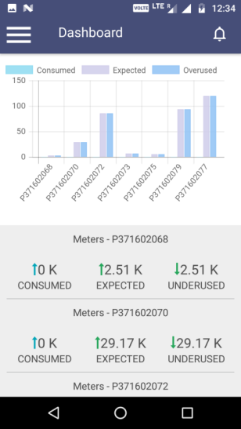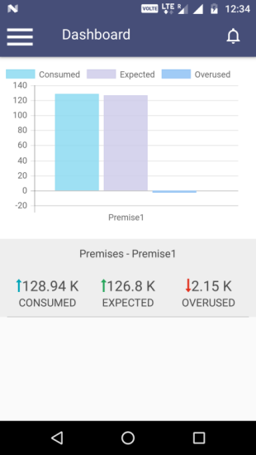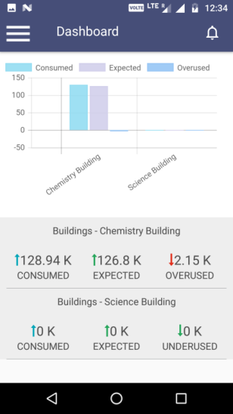

* + - * 1. **Alerts**

The Alerts menu shows all the alerts generated from Web or Data Services. User can click Acknowledge button to mark all alerts as viewed.

* + - * 1. **Insights**

The Insights menu lists all insights data for overall organization. It shows a sum of monthly details for all premises. Also, it displays a list of all the recommendations.

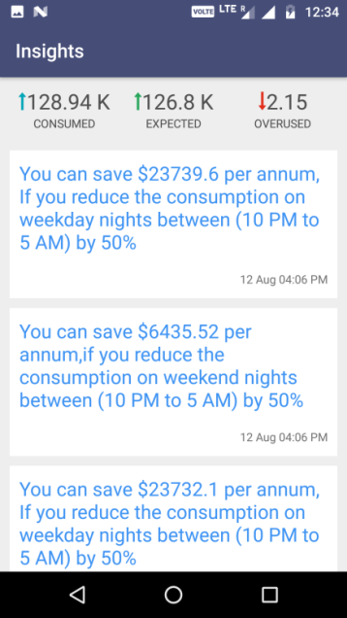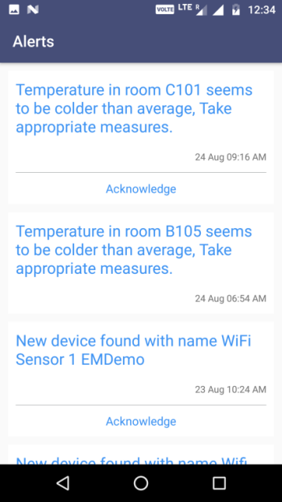

# Frequently Asked Questions

**Why can I see only the feedback screen?**On Sign Up, by default, a user is a non-admin user. This user has access only to the feedback screen/section. To view more features, user must request for change in permission/role to Admin role. For granting admin access, user must contact the Super Admin user to request for admin role.

**Power BI reports are not displayed.**To view the Power BI reports, it is necessary to configure Power BI. If the configuration is not done, user must contact the Super Admin to enable it instantly.

**App is asking for Domain URL on start up.**

The Energy Monitoring Mobile app requires Rest API URL for configuration. Users must contact their System admin and update the URL. It will ask the URL only once.

**Non - admin user does not receive notifications.**

Notifications are sent only to admin users. Non-Admin users can only submit feedback for rooms.

**After submitting feedback, Admin does not receive a notification.**

Notifications are sent only when the feedback ratio for that room on that day exceeds 60%.